CSCI441 Project Report
Title: Predicting Stock Price Direction Using Machine Learning Techniques
Stock Analyzed: NVIDIA (NVDA)
Course: CSCI441
Authors: Yousef Kahwaji, Ahmad Akoum, Mohammad Al Dirani

1. Introduction
Stock market prediction is widely known as one of the most difficult problems in data science. Financial markets are noisy, highly non-linear, influenced by countless external factors, and often violate the assumptions required by traditional machine learning models. The goal of this project is not to beat the market, but to evaluate how well various supervised and unsupervised machine learning models can predict short-term stock price direction (up, down) using technical indicators.
In this project, we attempt to predict whether the next trading day for NVIDIA (NVDA) will move UP or DOWN, based purely on historical price-derived features. We test multiple models, compare their performance, and analyze whether the limitation lies in the model choice or in the dataset itself.

2. Dataset Description

2.1 Data Source
The dataset was retrieved using the yfinance library, which provides historical stock market data directly from Yahoo Finance. We used the entire historical dataset for NVIDIA (NVDA) for the best result.

2.2 Original Features
The raw dataset contained the following columns:
- Open
- High
- Low
- Close
- Volume
- Dividends
- Stock Splits
The Dividends and Stock Splits columns were removed as they do not contribute meaningfully to short-term price direction prediction.

3. Feature Engineering
Feature engineering played a critical role in this project. Since raw prices alone don’t provide sufficient predictive patterns, we derived several technical indicators commonly used in financial analysis.

3.1 Trend Indicators (Moving Averages)
Simple Moving Averages (SMA) were calculated over multiple windows/days:
- SMA 20
- SMA 50
- SMA 100
- SMA 200
To capture how far the price deviates from its trend, we computed the relative distance between the closing price and each SMA: Close / SMA − 1
These features provide insight into whether the stock is overextended above or below its recent trend.

3.2 Momentum Indicators
Momentum measures the strength of price movement over time.
Relative Strength Index (RSI):
- RSI 14
- RSI 30
- RSI 90
RSI helps identify overbought and oversold conditions at different time horizons.
Rate of Change (ROC):
- ROC 5
- ROC 10
- ROC 20
ROC captures short-term and medium-term momentum in price changes.

3.3 Volatility Indicators
Volatility was calculated using rolling standard deviations of daily percentage returns:
- Volatility 5
- Volatility 10
- Volatility 20
These features quantify how unstable price movements are over different windows.

3.4 Price Structure Features
To avoid future data leakage while still capturing intraday structure:
- High Low range normalized by Close
- Open Close range normalized by Close
These features help represent daily price behavior without referencing future prices.

3.5 Trend Confirmation (MACD)
The Moving Average Convergence Divergence (MACD) was used:
- MACD line
- MACD signal line
- MACD difference
MACD provides a non-linear trend-following signal.

3.6 Time-Based Features
To capture potential seasonal or behavioral patterns:
- Day of the week (0–6)
- Month of the year (1–12)

3.7 NaNs
We intentionally left in the numerous NaNs generated during feature engineering to test how well the models handle null values.

4. Target Variable Construction
The prediction target was constructed as a binary classification problem.
- If the next day’s closing price increased by more than 0.5%, the label is UP
- Otherwise, the label is DOWN
This threshold (0.5%) was introduced to reduce noise from insignificant price movements.
The last row of the dataset was removed since it has no future value to compare against.

5. Model Evaluation Strategy

5.1 Metrics Used
Models were evaluated using:
- Accuracy
- Precision
- Recall
- F1 score
- Confusion matrices
Given the class imbalance and financial context, accuracy alone was not sufficient. Recall and precision for the UP class were especially important. (Done by classification report)

5.2 Data Splitting
Depending on the model, the following splitting strategies were used:
- Train/Test split (75% / 25%)
- K-Fold Cross Validation
- Stratified K-Fold
- Time Series Split
This ensured robustness and prevented overly optimistic results.

6. Model 1: Decision Tree Classifier

6.1 Reason
Decision Trees are interpretable, handle non-linear relationships, and require minimal preprocessing.

6.2 Models Tested
- Default Gini-based Decision Tree
- Entropy-based tree with class balancing
- Tuned Gini tree with depth control

6.3 Results
Accuracy ranged between 51% and 54%, barely outperforming a coin flip.
While some tuned models showed improved balance, all Decision Trees suffered from bias toward predicting DOWN, High variance, and Inconsistent recall for UP

6.4 Confusion Matrices
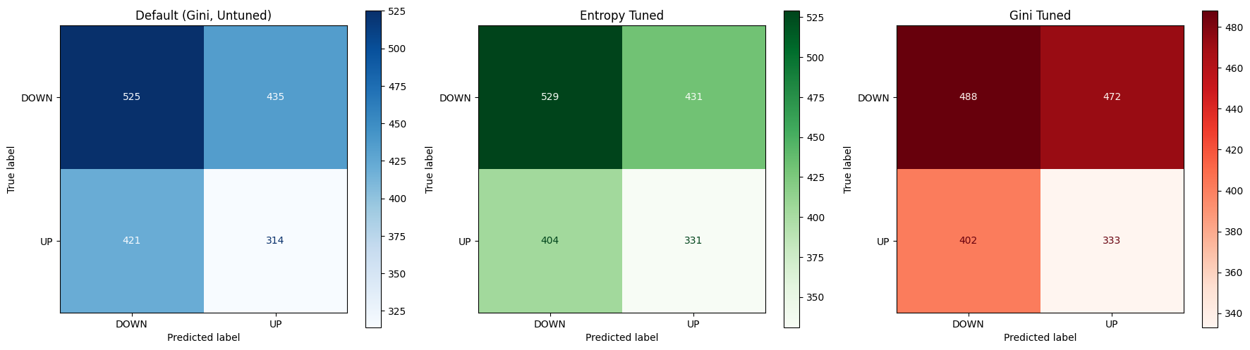

6.5 Conclusion
A single Decision Tree is not suitable for this dataset.

7. Model 2: Random Forest Classifier

7.1 Reason
Random Forests reduce overfitting by aggregating multiple Decision Trees and are generally stronger for tabular data.

7.2 Models Tested
- Default Random Forest
- Entropy-based balanced forest
- Tuned Gini forest with custom class weights

7.3 Results
Random Forests slightly improved stability but still struggled:
- Best accuracy remained close to 55%
- Severe bias toward DOWN in untuned models
- Balanced models sacrificed accuracy for balance between UP and DOWN

7.4 Confusion Matrices
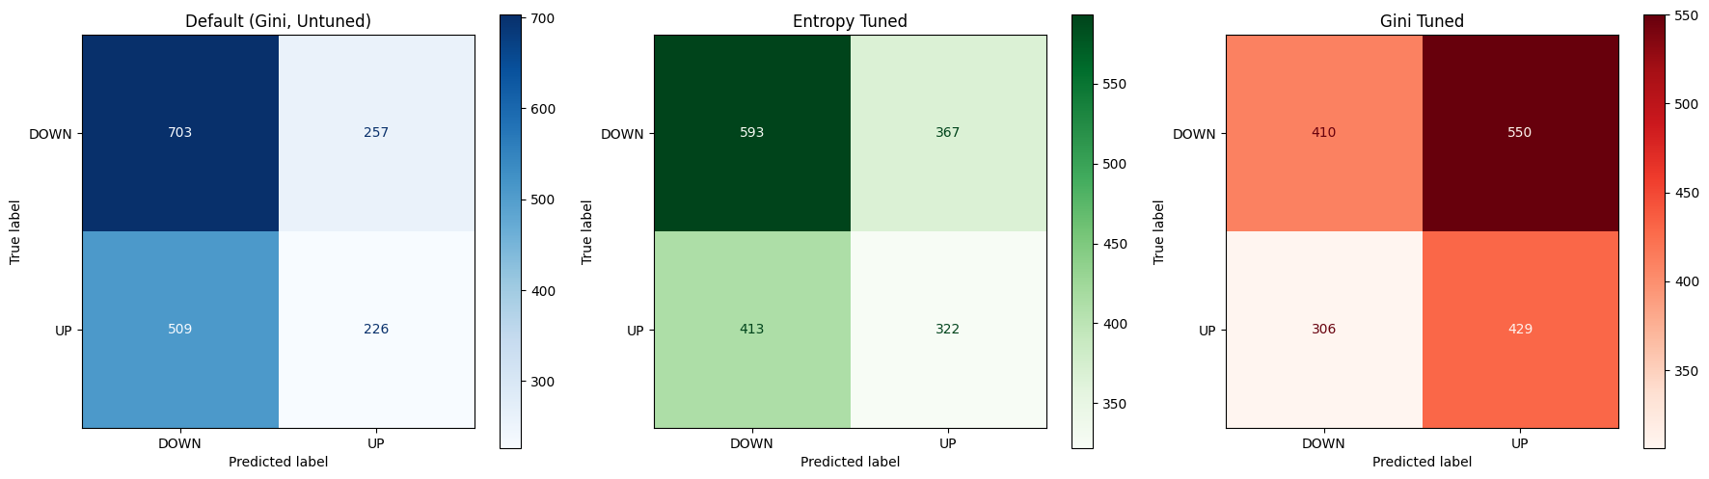

7.5 Conclusion
Despite being stronger than single trees, Random Forests were still unreliable for this task.

8. Model 3: K-Nearest Neighbors (KNN)

8.1 Preprocessing
- Removal of null values
- Feature scaling (StandardScaler)
- Dimensionality reduction using PCA (95% variance retained)

8.2 Models Tested
- k = 3
- k = 8
- k = √n

8.3 Results
- k = √n achieved the highest accuracy but had extremely low UP recall (~15%)
- Smaller k values improved balance but reduced accuracy

8.4 Confusion Matrices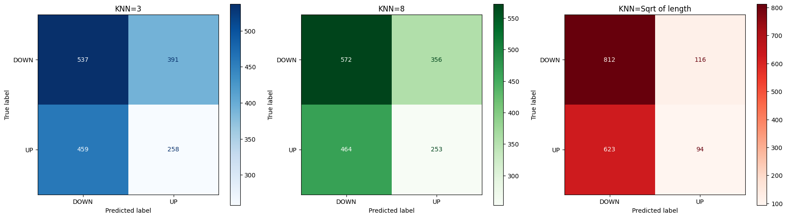

8.5 Conclusion
KNN consistently traded balance for accuracy and failed to generalize. It is not suitable for this dataset.

9. Model 4: Support Vector Machine (SVM)

9.1 Reason
SVMs are powerful for high-dimensional, non-linear data and can maximize class separation.

9.2 Models Tested
- Default RBF kernel
- Balanced Linear SVM
- Balanced RBF SVM

9.3 Results
- Default SVM achieved high accuracy but was extremely biased
- Linear kernel failed due to non-linear feature relationships
- Balanced RBF SVM achieved the best overall performance:
  - Accuracy ≈ 55.5%
  - UP recall ≈ 47%
  - Acceptable balance between classes

9.4 Confusion Matrices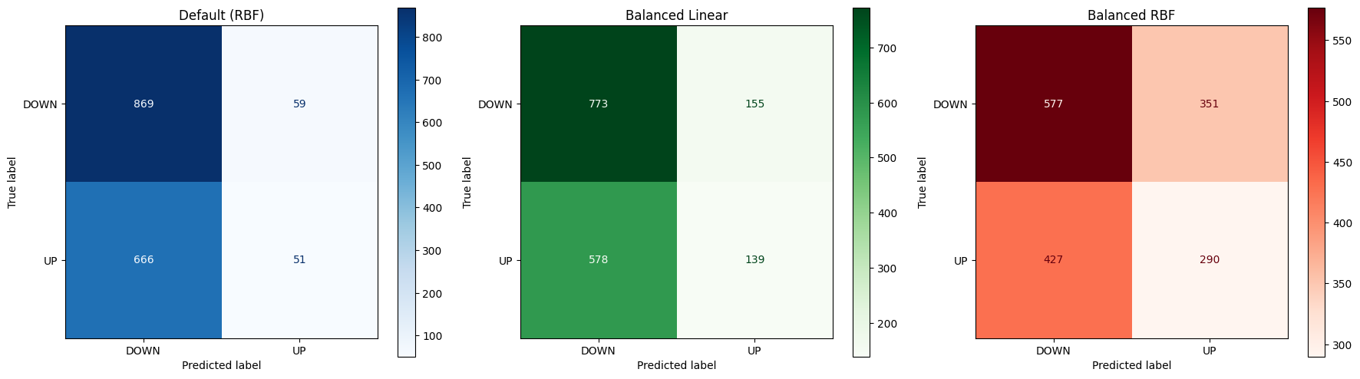

9.5 Conclusion
The Balanced RBF SVM was the best-performing supervised model, though still not fully ideal.

10. Bonus: Unsupervised Learning with K-Means

10.1 Reason
To determine whether the data naturally clusters into meaningful groups that resemble UP/DOWN behavior.

10.2 Steps
- Scaling
- PCA (2 components for visualization)
- K-Means with k = 2 and k = 4 (via elbow curve)

10.3 K=2 Scatter
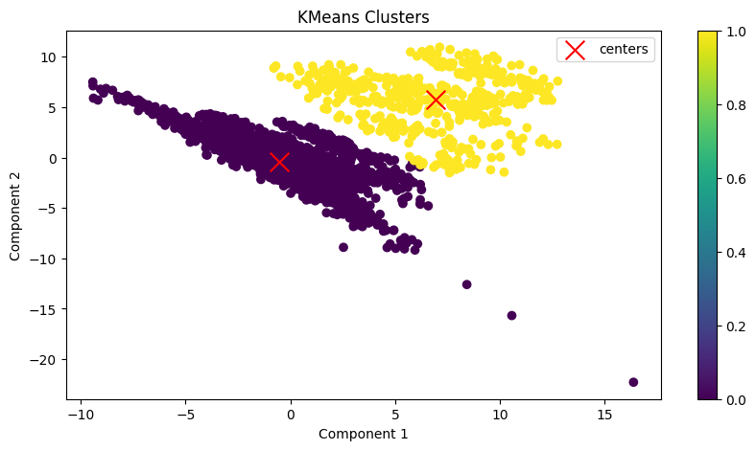

10.4 Elbow Curve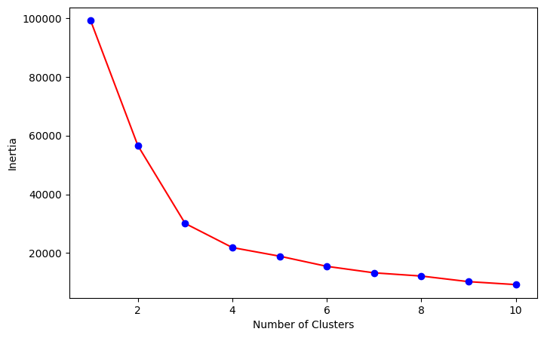

10.5 K=4 Scatte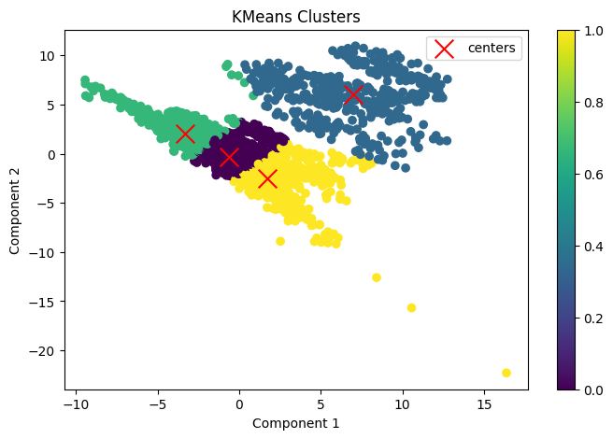

10.6 Results
- Extremely high inertia values
- No clear separation between UP and DOWN
- Clusters did not correspond to labels

10.7 Conclusion
The lack of meaningful clusters confirms that the dataset itself lacks a clear predictable structure.

11. Final Conclusion
Across all tested models:
- Trees struggled (DT)
- Ensembles struggled (RF)
- Distance-based models struggled (KNN)
- Clustering failed (KMeans)
- Even the best margin-based model barely exceeded random guessing (SVM)
This strongly suggests that the limitation lies in the dataset’s signal, not in the models used.
Stock price direction prediction using historical technical indicators alone is an inherently difficult problem, hence the low accuracy in all models used.
This project demonstrates that more complex models do not guarantee better predictions when the underlying data lacks predictive structure.

12. Key Takeaways
- Machine learning has limits in financial prediction
- Feature engineering is necessary but not sufficient
- Model evaluation must go beyond accuracy (balance)
- Financial markets remain highly volatile and noisy

